📄 Cover Page (Keep Short)

📄 About Us
About Indian Trade Mart
Indian Trade Mart is a rapidly growing B2B marketplace focused on connecting suppliers with genuine buyers across India. Our platform is designed to help manufacturers, wholesalers, traders, and service providers increase their business visibility and generate consistent inquiries.
We understand the challenges businesses face in finding reliable customers, which is why we provide a system that delivers targeted leads instead of random traffic. With a strong focus on trust, affordability, and results, Indian Trade Mart acts as a digital growth partner for businesses looking to expand in competitive markets.

📄 Founder’s Message
Dear Partners,
Mr. Prabhakar Dwivedi is a B-Tech (Civil), M-Tech (Structural), Chartered Structural Engineer, Chartered Engineer, Chartered Valuer & MBA. He has rich experience of more than 18 Years
It is with great pride and purpose that I welcome you to Indian Trade Mart — a dynamic B2B marketplace built with a clear mission: to empower businesses by connecting suppliers with genuine buyers and creating new opportunities for growth.
In today’s competitive and fast-paced business environment, companies need reliable platforms that can enhance visibility, generate quality leads, and drive consistent sales. Indian Trade Mart was created to address this need — as a powerful digital marketplace designed to simplify business networking, promote products and services, and deliver real buyer inquiries across India.
At Indian Trade Mart, we are committed to providing practical, result-driven solutions for businesses of all sizes. Our platform offers:
- Instant access to verified buyer inquiries
- Enhanced online visibility for your products and services
- Easy business profile setup and management
- Cost-effective marketing with measurable results
- Dedicated support to help you grow consistently
These features go beyond simple listings — they help build trust, improve business reach, and create long-term growth opportunities in the B2B ecosystem.
As Founder & CEO, my vision for Indian Trade Mart is to go beyond being just a marketplace. We aim to become a trusted business partner, helping organizations expand their reach, reduce marketing challenges, and achieve sustainable success.
Thank you for being a part of our journey.
With Warm Regards,
Mr. Prabhakar Dwivedi
Founder & CEO
Indian Trade Mart
📄 Our Services
Our Services
- ✔ Business Profile Listing
Create a professional online presence to showcase your company, products, and services to potential buyers across India.
- ✔ Product & Service Promotion
Display your offerings with proper details to attract relevant customers actively searching in your category.
- ✔ Verified Buyer Leads
Receive inquiries from genuine buyers, helping you connect with real business opportunities instead of unqualified traffic.
- ✔ Lead Generation Support
Continuous flow of inquiries to help you maintain consistent business growth and sales opportunities.
- ✔ Inquiry Management Assistance
Support in handling and responding to buyer inquiries efficiently for better conversion rates.
- ✔ Enhanced Visibility Solutions
Improve your ranking and reach on the platform to stand out among competitors.
- ✔ Dedicated Customer Support
Get assistance from our team for onboarding, profile setup, and performance improvement.

📄 Starter Plan – Free Trial
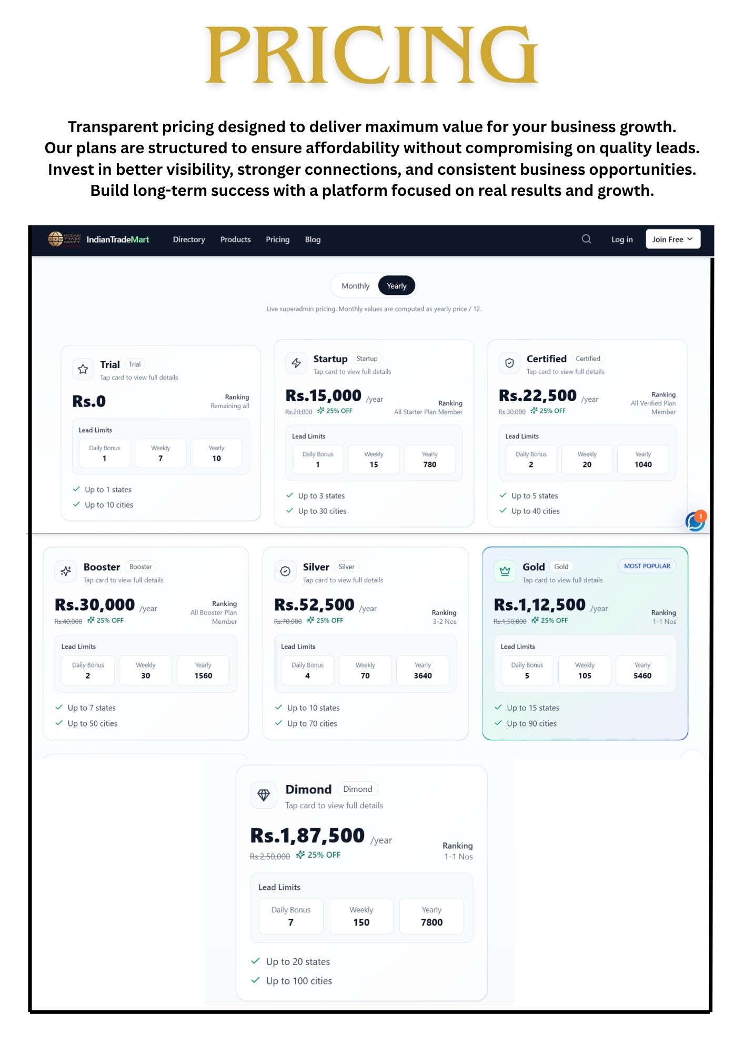
Starter Visibility Plan (Free Trial)
Our free trial plan is designed to give businesses a risk-free opportunity to experience real results before making any investment. With this plan, you can create your business profile, upload products or services, and start receiving initial buyer inquiries.
This allows you to understand how the platform works and evaluate the quality of leads generated. We believe in building trust first, which is why we offer a “results-first” approach. It is ideal for small and medium businesses looking to explore online B2B growth without financial risk.

📄 Premium Plan (Expanded)
Business Growth Plan
The premium plan is built for businesses that want to scale faster and gain a competitive edge in the market. It offers enhanced visibility, priority listing, and access to a higher volume of buyer inquiries.
With dedicated support and improved exposure, your products reach a wider and more relevant audience. This increases the chances of conversions and long-term business opportunities. The plan is structured to deliver measurable growth and consistent lead flow, making it suitable for serious businesses aiming for expansion.

📄 Why Choose Us
Why Choose Indian Trade Mart
Indian Trade Mart stands out by focusing on real results rather than just listings. We follow a customer-first approach where businesses can experience the platform before making any payment. Our system is designed to deliver genuine buyer inquiries, helping you connect with real customers instead of wasting time on unqualified leads.
We offer affordable pricing, easy onboarding, and continuous support to ensure smooth operations. Whether you are a small business or an established supplier, our goal is to help you grow with confidence and reliability.

📄 How It Works
Getting started with Indian Trade Mart is simple and efficient. First, you register your business and create a professional profile on the platform. Next, you list your products or services with relevant details to attract potential buyers.
Once your profile is active, you begin receiving inquiries from interested customers. Our system ensures that these inquiries are relevant to your business category. You can then connect with buyers, negotiate, and convert these leads into actual sales. The entire process is designed to be user-friendly and result-oriented.

📄 Contact / CTA
Start Your Free Trial Today
Take the first step towards growing your business with Indian Trade Mart. Our platform is built to deliver real results, helping you connect with buyers who are actively looking for your products and services.
With a risk-free trial, you can explore the benefits without any upfront investment. Our team is always ready to assist you in setting up your profile and maximizing your visibility. Don’t miss the opportunity to expand your reach and increase your sales. Contact us today and start receiving genuine business inquiries.

